This is an improved version of HW#1, actually redid it.

As soon as the application starts it will run the default mode which is the “lines” mode. Refer to figure 1 for example

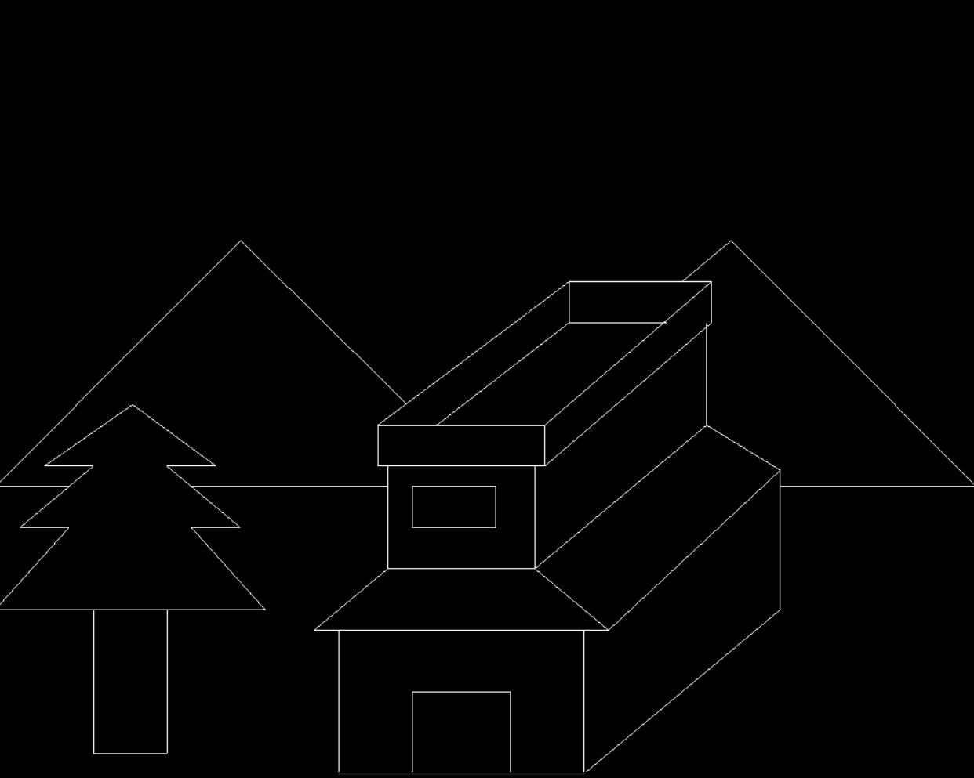

Figure

This is an interactive program, the user can press on their keyboard, “n” for night, “d” for day or “b” for lines, Figure 2 is an example of a day, Figure 3, is an example of a night.

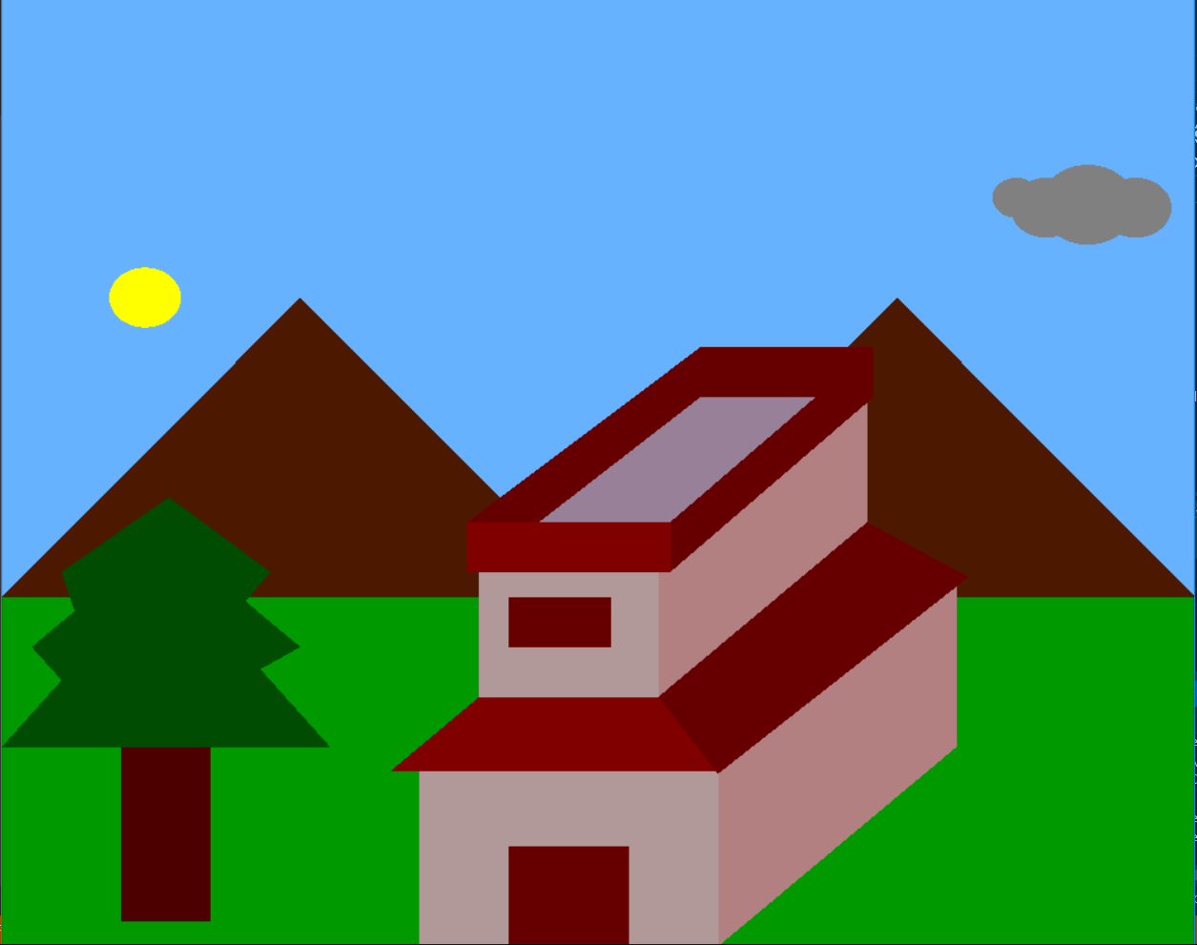

Figure

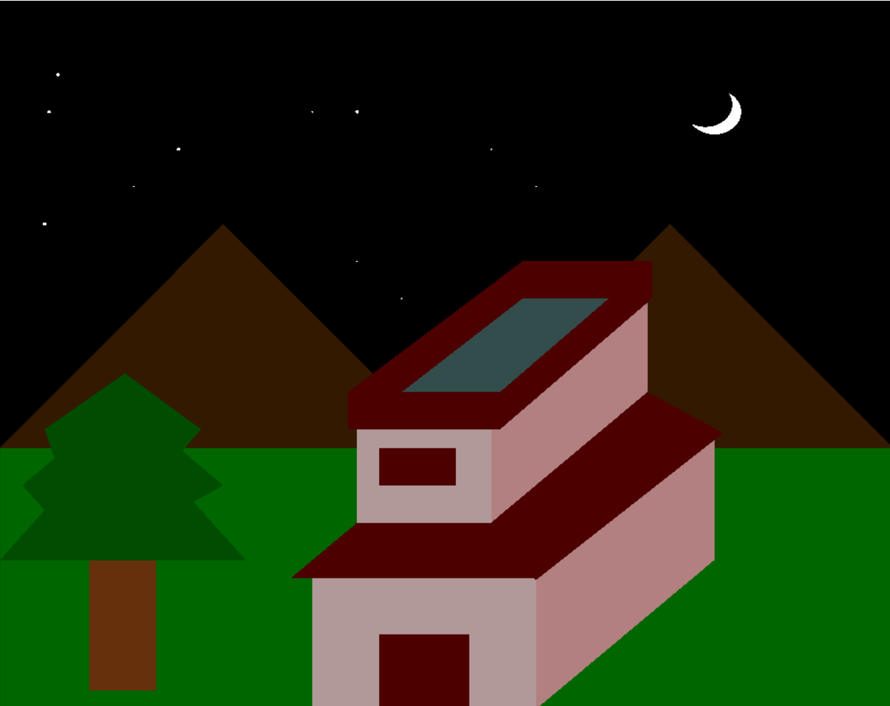

Figure

In addition to this interaction one can switch between moons from beginning to full moon to disappearing moon by pressing “m” multiple times and the animation will play, every time “m” is pressed a new frame will be drawing. Refer back to Figures 4~6 for examples.

|  |  |  |
| --- | --- | --- |
| C:\Users\Muhand\AppData\Local\Microsoft\Windows\INetCacheContent.Word\output_night_1.png  Figure | C:\Users\Muhand\AppData\Local\Microsoft\Windows\INetCacheContent.Word\output_night_2.png  Figure | C:\Users\Muhand\AppData\Local\Microsoft\Windows\INetCacheContent.Word\output_night_3.png  Figure |

Not only night can be animated but day can be animated as well. By pressing “s” one can animate day, refer back to Figures 6~9 for examples

|  |  |  |
| --- | --- | --- |
| Figure | Figure | Figure |

Also by Pressing the CAPS LOCK colors will change.